The Diderot Mathematical Forum 2013 in Berlin, Exeter and Zagreb
(Ehrhard Behrends, Franka Miriam Brückler, Mireille Chaleyat-Maurel)

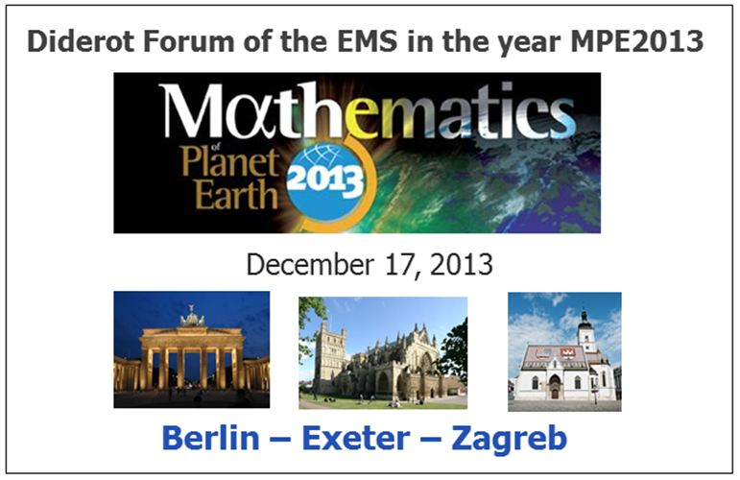

The cycle of conferences "Diderot Mathematical Forum" was introduced by the EMS in 1996. Each conference takes place simultaneously in three European cities exchanging information by telecommunication, addresses a specific topic, and has both a research and a public component. So far, there have been five Diderot Mathematical Forums: Mathematics and finance (London, Moscow, Zürich, 1996); Mathematics and environment: Problems related to water (Amsterdam, Madrid, Venice, 1997); Mathematics as a force of cultural evolution (Berlin, Florence, Krakow, 1998); Mathematics and music (Lisbon, Paris, Vienna, 1999); Mathematics and telecommunications (Eindhoven, Helsinki, Lausanne, 2001). As the year 2013 was the international year of Mathematics of planet Earth (MPE2013, see http://mpe2013.org/ ), the Committee for Raising Public Awareness of Mathematics of the EMS, the rpa committee, initiated the renewal of the cycle for 2013 with the topic Mathematics of planet Earth.
The coordinators of the event were Mireille Chaleyat-Maurel (Université Paris Descartes, Paris), Franka Miriam Brueckler (Faculty of Science, Zagreb) and – as the chair of the rpa committee of the EMS – Ehrhard Behrends (Freie Universität Berlin).

The Diderot Forum took place in the afternoon of December 17, 2013, in Berlin (Germany), Exeter (UK) and Zagreb (Croatia). The general public was invited to attend this event.

Here are the time table and the titles of the talks:
Berlin
17:00 – 17:45 Rupert Klein, FU Berlin: How math helps structuring climate discussions
17:45 – 18:30 Klaus Eisenack, Universität Oldenburg: About use and misuse of mathematics in social sciences
18:30 – 19:15 Bjorn Stevens, Direktor des Max-Planck-Instituts für Meteorologie, Hamburg: Powerful consequences of simple ideas ... the mathematics underlying understanding of climate change
Exeter
14:30 – 15:15 Mark Baldwin, University of Exeter: A conceptual model of stratosphere-troposphere coupling
16:00 – 16:45 Mat Collins, University of Exeter: Understanding and Quantifying Future Climate Change
17:45 – 18:30 David Stephenson, University of Exeter: Mathematical modelling of Clustering of Natural Catastrophes
18:30 – 19:15 Peter Cox, University of Exeter: Will the Amazon forest survive climate change? The answer is in the noise
Zagreb
14:30 – 15:15 Eduard Marušic-Paloka, University of Zagreb: Mathematical modelling of nuclear waste disposal site
15:15 – 16:00 Senka Macešic and Nelida Crnjaric-Žic, University of Rijeka: Backward-in-time probabilistic method applied to the Gulf of Mexico oil spill
17:45 – 18:30 Branko Grisogono, University of Zagreb: What do climate models and we know about Bora-like windstorms?
18:30 – 19:15 Franka Miriam Brueckler and Vladimir Stilinovic, University of Zagreb: From bathroom tiles to quasicrystals - chemical applications of normal tessellations

The Diderot forum started at 2 pm in Zagreb with an introduction to this event given by Mireille Chaleyat-Maurel; this was broadcasted to Berlin and Exeter. She explained the connection with MPE2013 and communicated a welcome address by Marta Sanz-Solé, the EMS president.

Three of the talks (Senka Macešic and Nelida Crnjaric-Žic, Mat Collins, Rupert Klein) were declared as “non-parallel talks”: they were broadcasted in real time to the other two cities and as a life stream to special webpages. Also video recordings were produced for all 11 presentations. The corresponding links can be found on www.mathematics-in-europe.eu/1031. The talks and the video streams attracted the attention of many visitors.

After the talks and a short break an electronic round table discussion (chaired by Rupert Klein) between the speakers took place: what is the significance of mathematics in connection with the most urgent problems of mankind in the future (climate, sustainability, ecology, how to stop the global warming, …)?

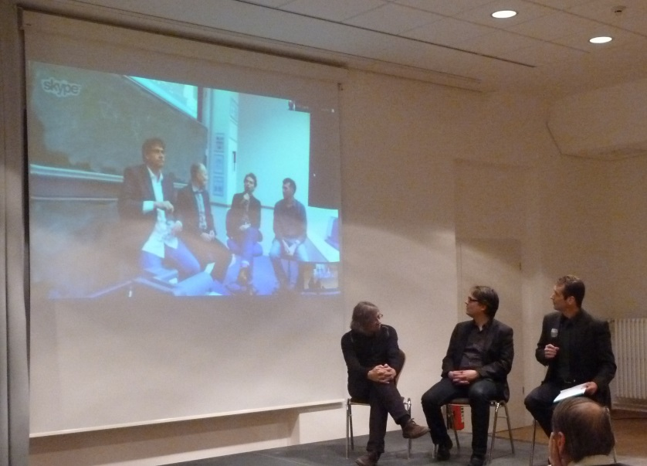
The speakers from Berlin discuss with the Exeter team (on the screen).

The Diderot Forum terminated with some closing remarks by Mireille Chaleyat.

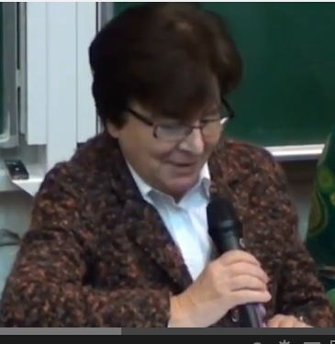
Closing remarks by Mireille Chaleyat

In particular she stressed that the efforts to communicate the “Mathematics of Planet Earth” will continue. (Cf. also the corresponding press release on http://mpe2013.org ).

In this connection one should note that the associated webpage www.mathematics-in-europe.eu/1031 has by now, January 2014, been visited by more than 25.000 people.

